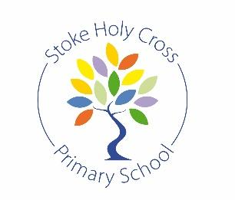
Year 4 Curriculum Overview – Autumn
The following is a brief overview of what pupils will be studying during the Autumn Term in Year 4. Our topic this term will be the Ancient Greeks.
In the event that home learning is required, information can be found in the highlighted sections below. Further resources can also be found on the school’s Google Drive folder:
https://drive.google.com/drive/u/0/folders/1nUvXasgb3E-6OakSnhaD2Of_iUGeiJvP
English:
- Recounts and reports
- Greek Myths https://tinyurl.com/yxb6wyy5
- Nonsense Poetry
- Explanation Texts https://tinyurl.com/y6jgwmyo

Maths: https://whiterosemaths.com/resources?year=year-4-new&term=autumn (accompanying worksheets in Google Drive area)
- Place value
- Number: addition and subtraction
- Measurement: area
- Number: multiplication and division

Science:
- States of matter https://tinyurl.com/y37m9dfj
- Sound https://tinyurl.com/y5ys5j9l
Art & Design:
- Greek pottery https://classroom.thenational.academy/units/ceramics-8b02
Music:
- Recorders
PSHE
- Me and my relationships https://tinyurl.com/y5e7jnaa
- Valuing differences https://tinyurl.com/y37y77m9
History & Geography:
- European geography. https://classroom.thenational.academy/units/building-locational-knowledge-europe-0322
- A study of Ancient Greek life and their influence on modern society. https://tinyurl.com/y8746fu2
Computing:
- E-safety
- Internet researching skills https://classroom.thenational.academy/units/sharing-information-adc8

Physical Education: Super Movers Champions - Active Me - BBC Teach
- Football
- Sportshall athletics
- Gymnastics (flight)
- OAA (team-building)
Foreign Languages:
- Portraits: describing in French https://classroom.thenational.academy/units/cest-moi-b60c
- Clothes: get dressed in French
https://classroom.thenational.academy/units/je-mhabille-4064

Religious Education:

- How special is the relationship Jews have with God?
- What is the most significant part of the Nativity story for Christians today?

